Frontend Coding Assignment

**Duration:** 2 hrs

**Problem Statement**

Build a simplified version of the Github’s issues page (Example - [angular issues page](https://github.com/angular/angular/issues))

With the following features:

1. Listing of issues
2. Pagination Controls (Server side pagination)
3. Search open issues
4. Issue Details page Fig (2)
5. Labels Filter (*Bonus feature*)

**API Details**

Sample Requests:

1. To get repository details like name, open issues count etc

<https://api.github.com/repos/angular/angular>

2. Search Issues / Listing with pagination

<https://api.github.com/search/issues?q=repo:angular/angular/node+type:issue+state:open&per_page=10&page=1>

3. Issue details - the results returned by search API will contain a field called `url`, issue details can be obtained by making an api call to this.

"url": "<https://api.github.com/repos/angular/angular/issues/37955>"

For more details:

* [Github API documentation - get repository details](https://docs.github.com/en/rest/reference/repos#get-a-repository)
* [Github API documentation - search issues](https://docs.github.com/en/rest/reference/search#search-issues-and-pull-requests)

Because this is a brief exercise and not a full fledged app, you may make the following assumptions:

* The app will only access public information, so no authentication of any kind is required.
* We know making a great-looking UI takes a lot longer than 2 hours. Your UI should be functional and responsive, but is not expected to be attractive.

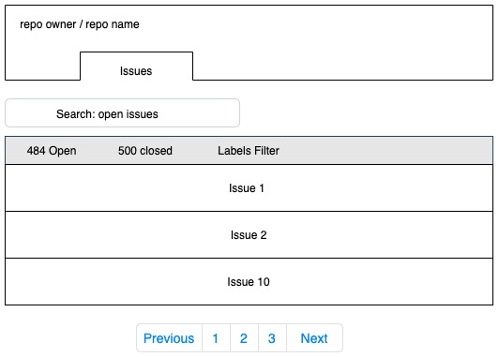

Fig (1) - Issues Homepage

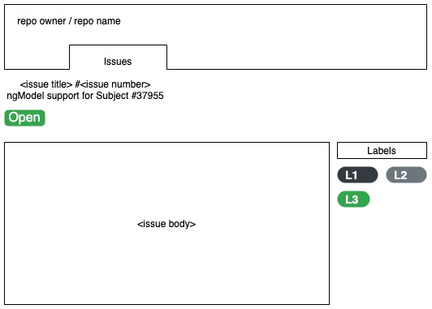

Fig (2) - Issue detail page